**Database and file Management Systems** (CIS 2109)

1. **Reference Chapters 6 and 7 in "Modern Database Management"**

a. Open Oracle SQL Developer and connect to the database following the instructions in the file Connection_Instructions.doc

b. Download from canvas the file: Lab_01_scripts.sql and open it in Oracle SQL Developer using:

File -> Open and browse to locate the Lab_01_scripts.sql file

c. Execute ALL the commands in this file by clicking on the button shown in the figure:

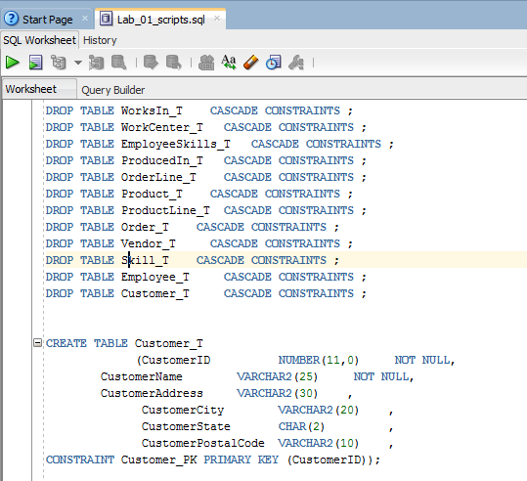

d. Now you have tables and data in your database!

e. Take a look at the data and answer the following questions:

1. What is the datatype of the field Invoice_Date in Invoices?

Date

1. If you try to insert an invoice record with empty Invoice_Date will you be able to?

No, the table says the invoice date field is not nullable.

1. What is the maximum possible length for the Customer_State field? Would you be able to insert a customer with Customer_State = ‘New York’;

2 characters, New York would not fit, they’d have to go with NY.

1. Who is the customer with Customer_ID = 12?

Rohansen Anders

1. How many orders has this customer placed?

2 orders, numbers 651 (item ID 3) and 658 (item ID 1)

1. Which Products has this customer purchased?

They purchased Umani in Concert by Umani, and No Rest For The Weary by No Rest For The Weary

1. If you wanted to insert the following record in table ORDER_DETAIL should you be able to? Will you able to do it? Yes/No and why.

No, because an Item ID of 12 does not exist, and it doesn’t include any information about the customer.

|  |  |  |
| --- | --- | --- |
| ORDERID | ITEMID | ORDER_QTY |
| 442 | 12 | 5 |

**Part 02**

Write the DML select statements to create the following reports:

**Deliverables:**

For each query upload a screenshot showing the query and the results. You should also **write** the query.

1. Write a query that returns the first name and state of each customer.

SELECT CUSTOMER_FIRST_NAME, CUSTOMER_STATE

FROM CUSTOMERS;

1. Write a query that returns the first name and state of each customer but for only those customers who live in a city named ‘Fairfield’

SELECT CUSTOMER_FIRST_NAME, CUSTOMER_STATE

FROM CUSTOMERS

WHERE CUSTOMER_CITY=’Fairfield’;

1. Write a query that returns the first name and state of each customer but for only those customers who do not live in NY.

SELECT CUSTOMER_FIRST_NAME, CUSTOMER_STATE

FROM CUSTOMERS

WHERE CUSTOMER_STATE!=’NY’;

